5/6/2020

Solution Manager Training

H1 2020

*BASIC CONFIGURATION – Solution Manager 7.2*

Author : Sweetha Shankaravelu

**Basic Configuration.**

**Overview –What will be done:**

▪**Configure Basic Functions**

**▪Schedule Jobs**

**▪Configure Manually**

**▪Create Basic Dialog Users**

**Configure Basic Functions.**

In this step SAP Solution Manager automatically executes configuration activities. To start the automatic configuration, select the *Execute All* pushbutton:

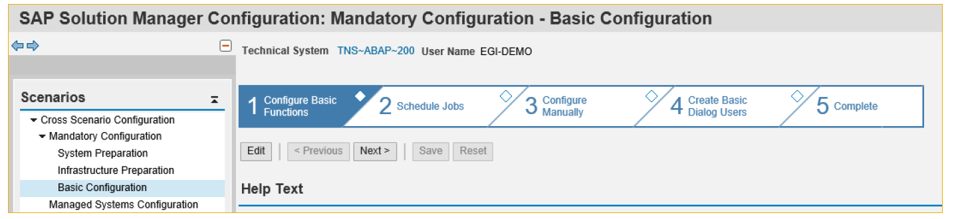

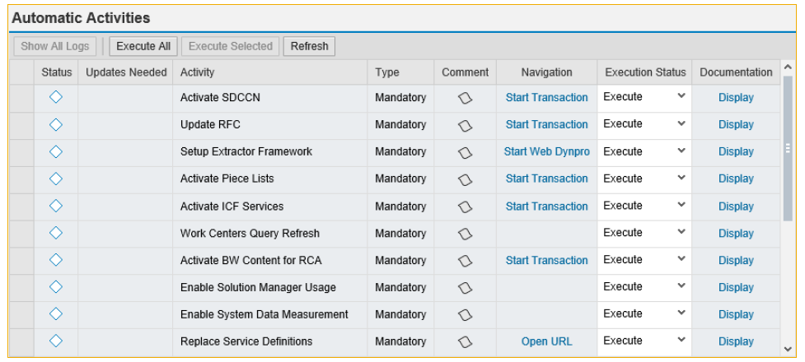

This step is needed to configure root cause analysis, service delivery, EarlyWatch Alert, and self-monitoring.

**Automatic Activities.**

1. For each activity you want to execute, select the activity and click Execute Selected.
2. For each activity you want to skip, select the postponed status.
3. To execute all automatic activities, select Execute All.
4. You can also perform the activities manually.
5. In the Documentation column, choose the Display link to open the activity-specific documentation.
6. Choose the link in the Navigation column and follow the instructions in the documentation.
7. If the activity was performed successfully, select Manually Performed.
8. If error occurred, select Manually Performed with Errors.

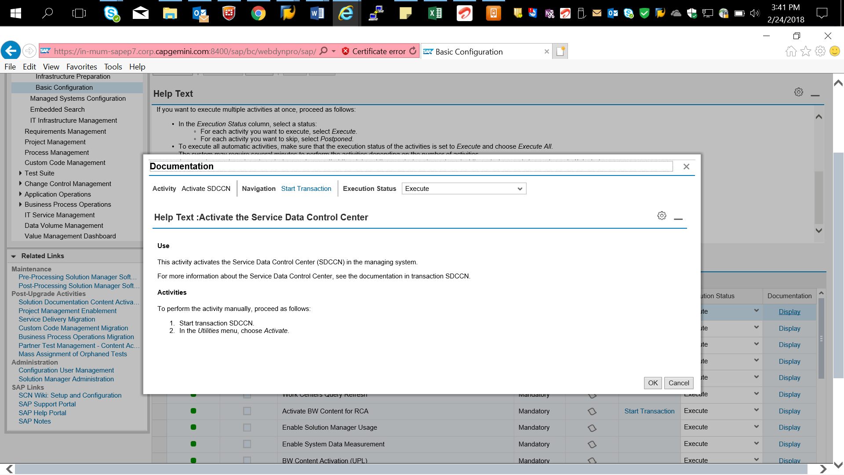

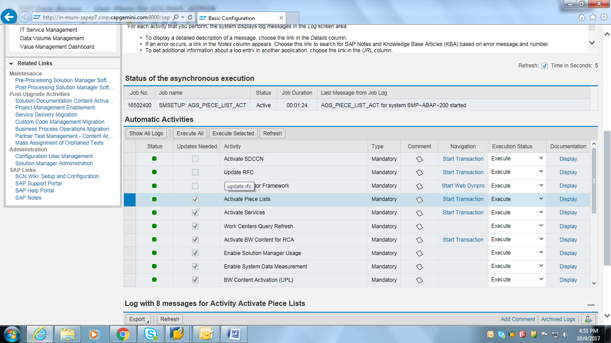



In this step SAP Solution Manager automatically executes configuration activities. To start the automatic configuration, select the Schedule Jobs as Planned pushbutton:

**Schedule Jobs.**

Note that the availability and behavior of job scheduling actions depends on the system role that you selected for this SAP Solution Manager system (*Mandatory Configuration* -> *System Preparation* -> *Define System Role*)

In a **production system**, all recommended SAP Solution Manager jobs are scheduled, including those receiving or sending data to SAP Support Portal.

In other systems (for development, testing etc.), you usually decide which of the SAP Solution Manager jobs that receive or send data to SAP Support Portal are to be scheduled.

In this step, you schedule important jobs needed by SAP Solution Manager.

This activity creates most of the main job schedules necessary for SAP Solution Manager. Existing job schedules are checked, and changed or removed if they are obsolete. We do not recommend performing this activity manually, job by job, using transaction SM36, as each job has its own job definition in an SAP-internal configuration table, with an appropriate periodicity and start time.

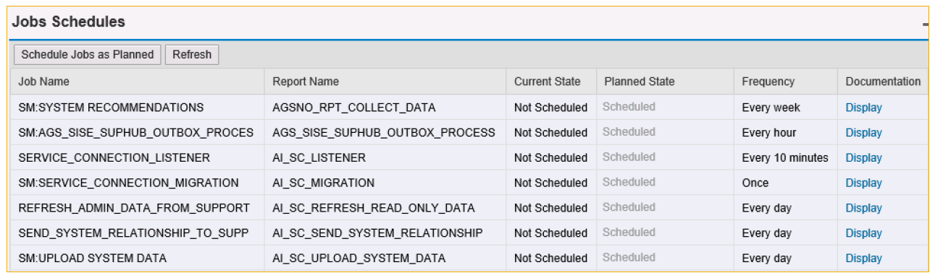

**Note:** The scheduling of SAP Solution Manager Background Jobs can take about 15 minutes. Do not re-execute the activity until all immediate jobs started. (Refresh) After the configuration, messages and other detailed information are displayed in the log area.



**Configure Manually.**

**Manual Activities**.

1. In the Documentation column, choose the Display link to open the activity-specific documentation.
2. Choose the link in the Navigation column and follow the instructions in the documentation.
3. If the activity was performed successfully, select Performed.
4. If error occurred, select performed with Error.
5. Perform all Manual Activities in same procedure.

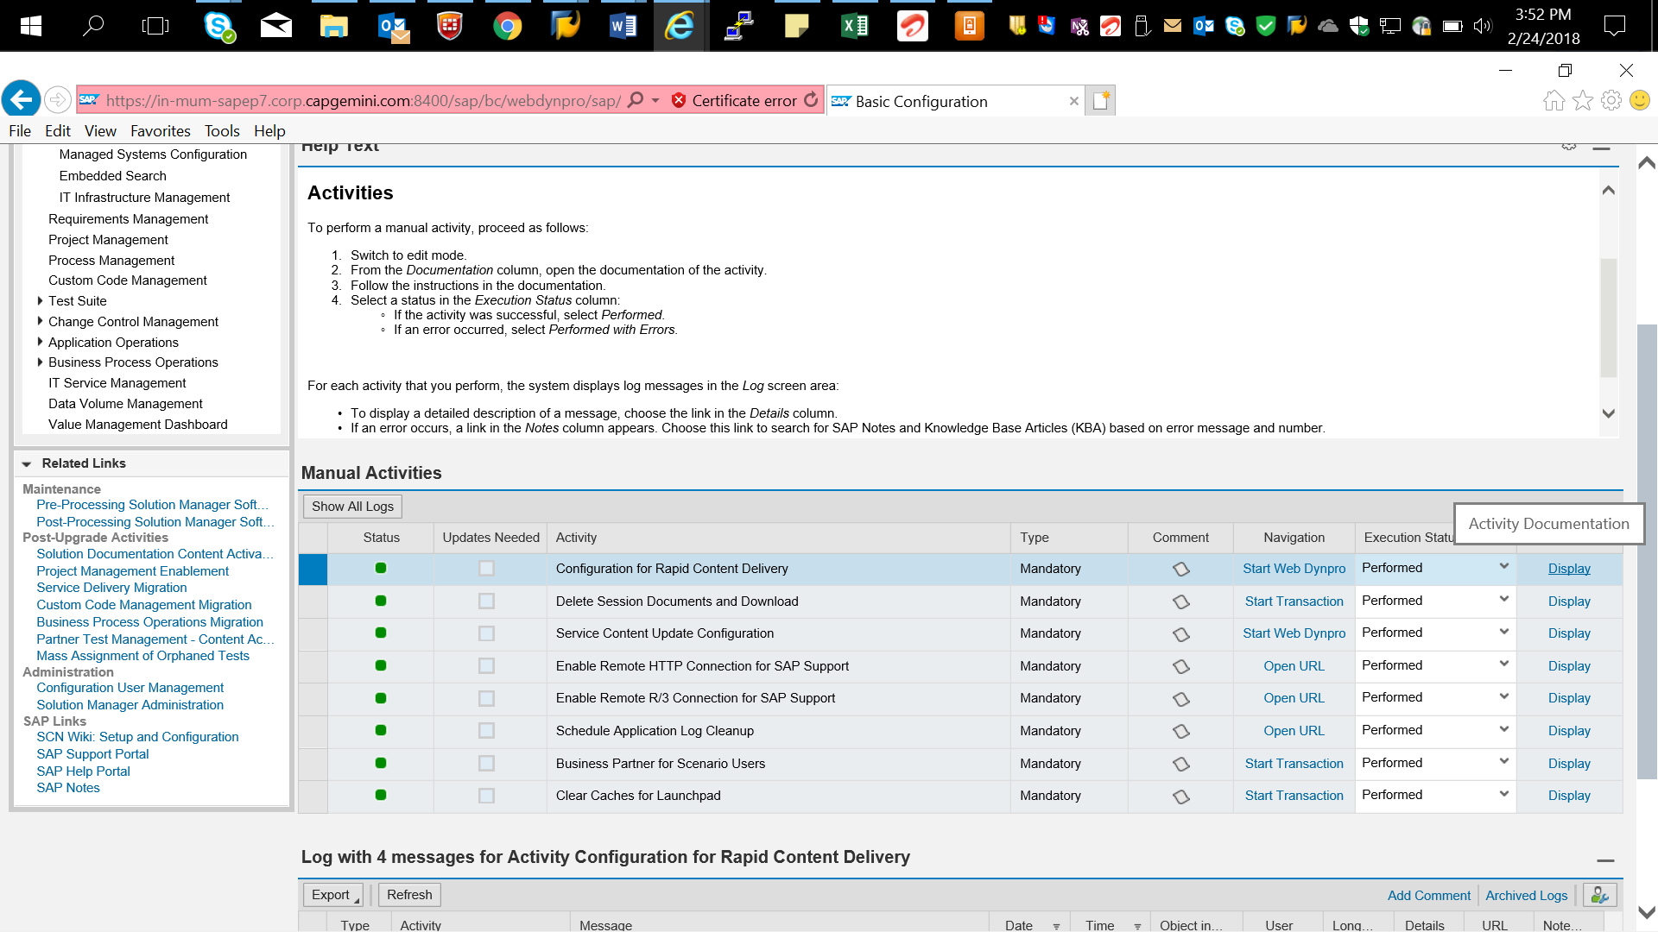

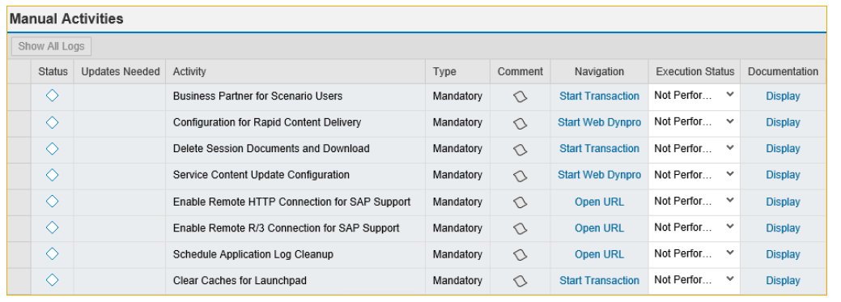

**Service Content Update Configuration**

The service content update offers a method to keep the EarlyWatch Alert and other SAP services up-to-date. Instead of applying ST-SER Support Packages you activate the service content update once.

The SAP Solution Manager will then retrieve the latest corrections for SAP services from the Service Marketplace.

Tomanage the service content update you can use the link provided in transaction SOLMAN_SETUP or go directly to transaction AGS_UPDATE. Mark the settings as shown and select *Confirm*. Ensure that the job is shown as scheduled (you may need to press *Confirm*again). Please refer to SAP Note 1143775 for more info.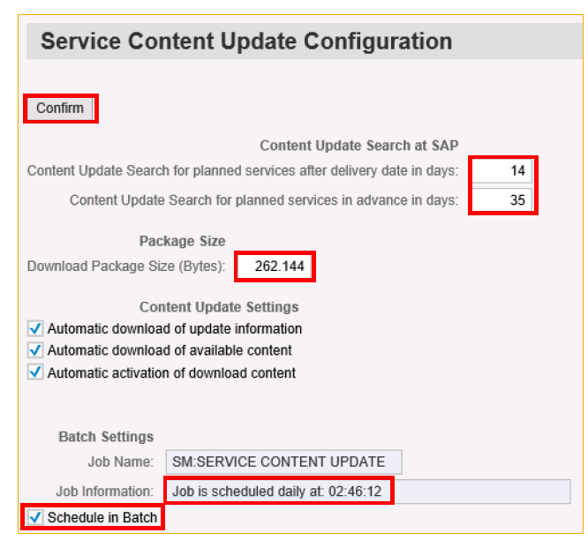

**Configure Manually –Clear Caches for Launchpad**

**This activity invalidates all server-side caches in SAP NetWeaver user interface services.**

We recommend to execute this activity with every implementation of a support package for SAP Solution Manager or with every implementation of a SAP Note for SAP Solution Manager that delivers changes to tiles in the Solution Manager Launchpad.

Reset UI caches by calling transaction SA38 to run reports

**▪/UI2/INVALIDATE_GLOBAL_CACHES**

**▪/UI2/INVALIDATE_CLIENT_CACHES**

**▪/IWBEP/R_MGW_MED_CACHE_CLEANUP**



In this step, you create or update users (of type Dialog) and assign roles to them. For more information about the individual users select the Display link in the Documentation column. Select the relevant user, enter the password and select Execute pushbutton.

**Create Basic Dialog Users.**

1. This only applies to users in the SAP Solution Manager system, not in BW systems and managed systems
2. In this step, you create or update dialog, technical (of type *System*) or BW users, and assign roles to them, depending on the scenario and step
3. In the System Preparation scenario, Maintain Technical Users step, you create technical users (of type System).
4. In the Infrastructure Preparation scenario -> Set Up BW step -> Maintain Users step, you create BW users.
5. In the Basic Configuration scenario, Create Basic Dialog Users step, you create dialog users.

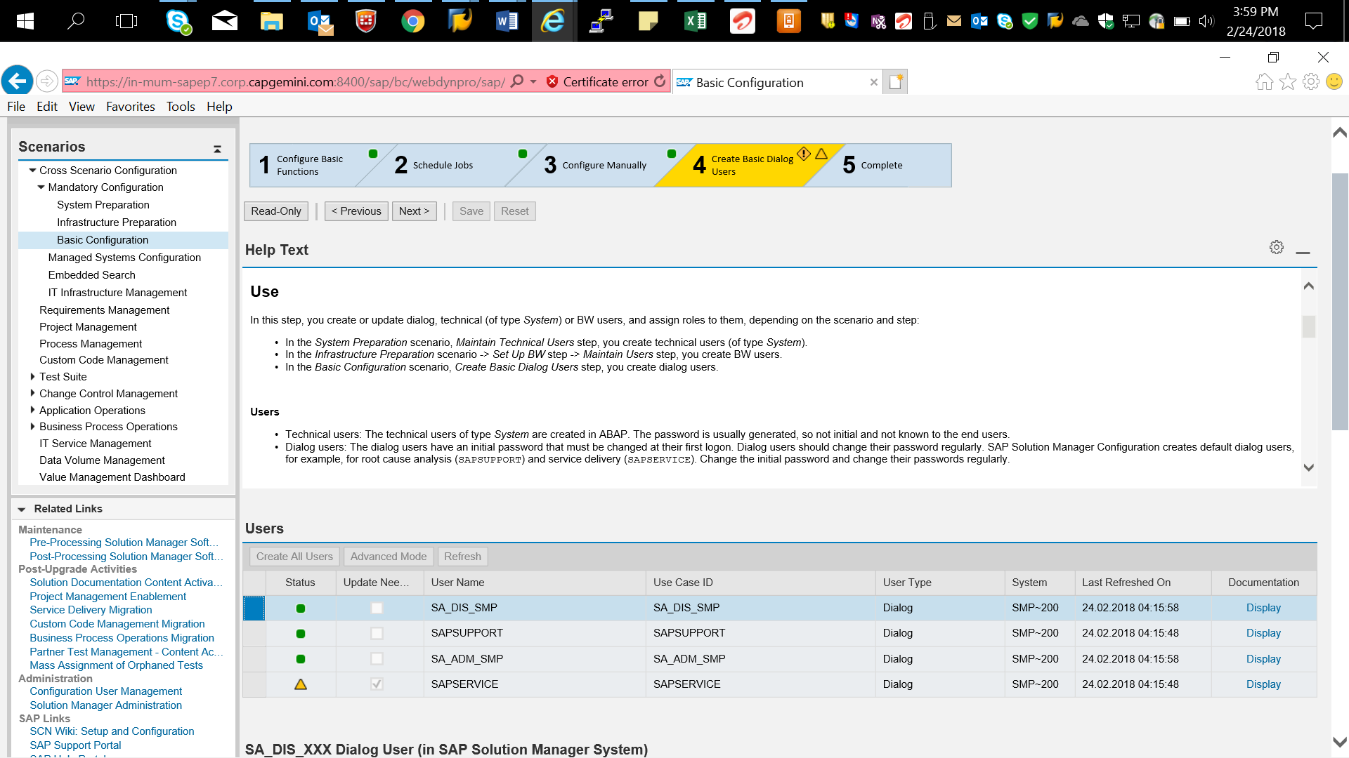

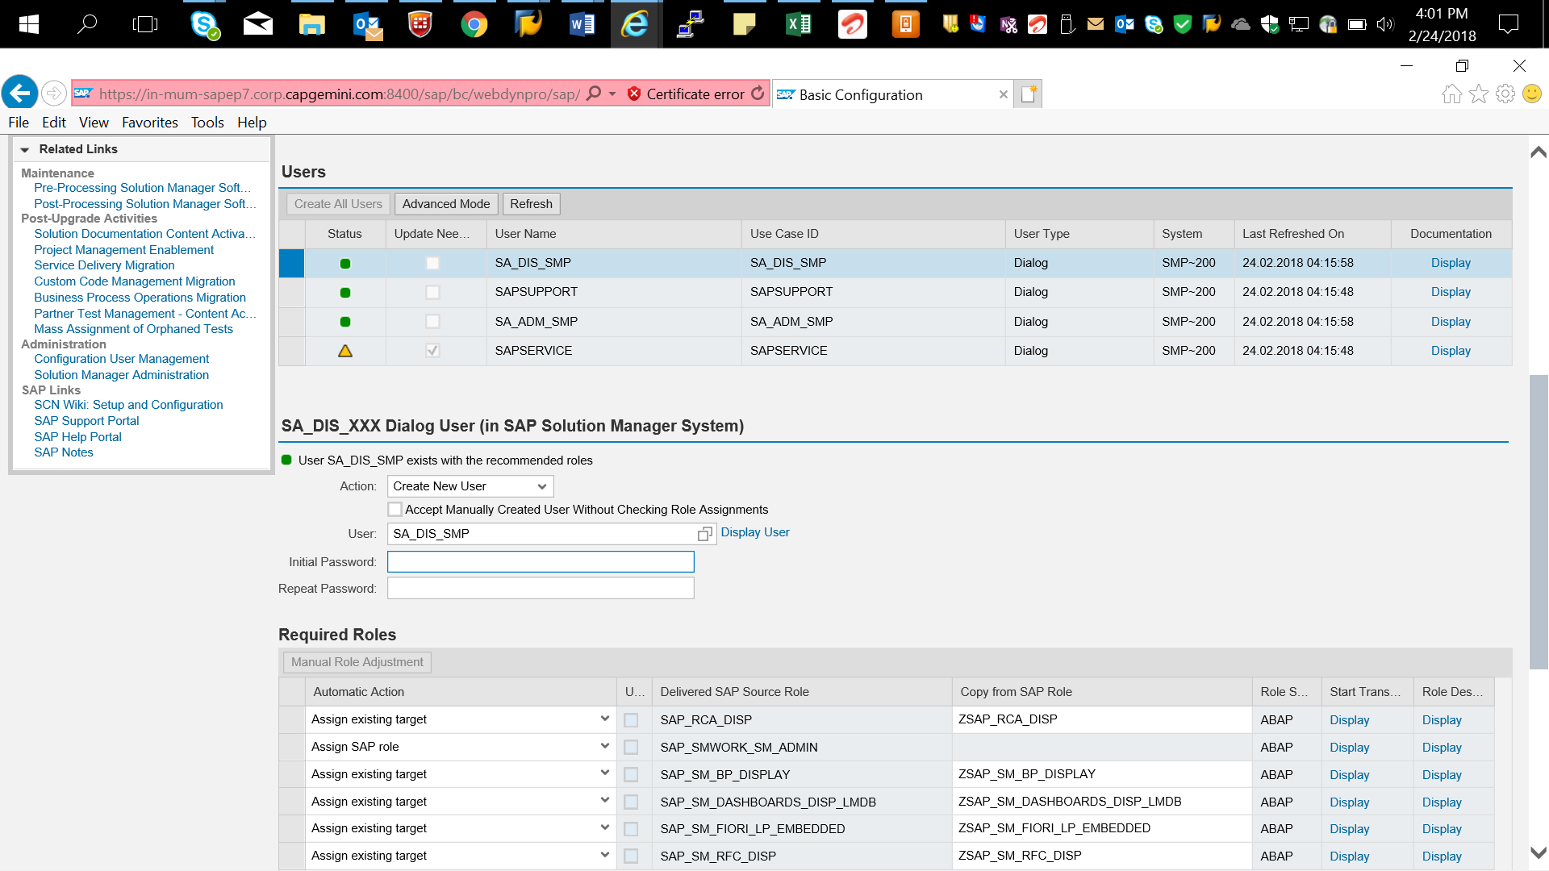

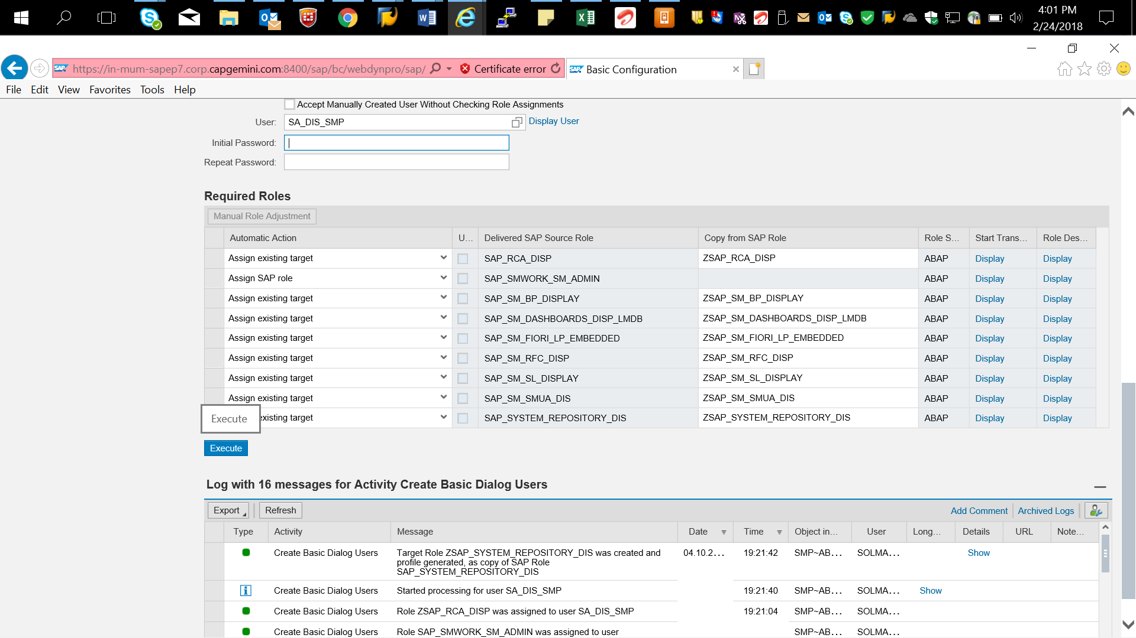

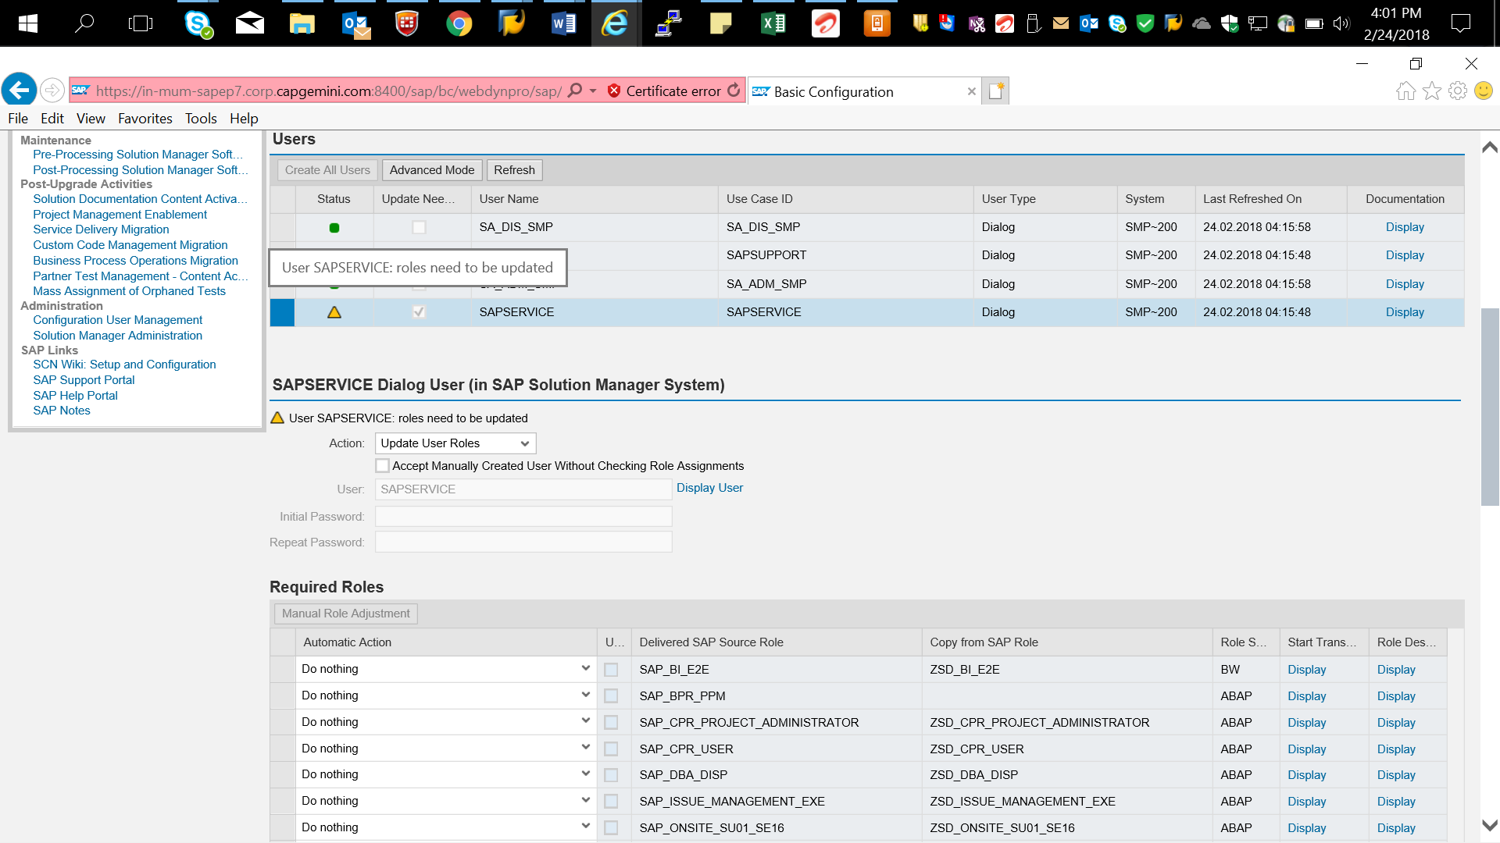

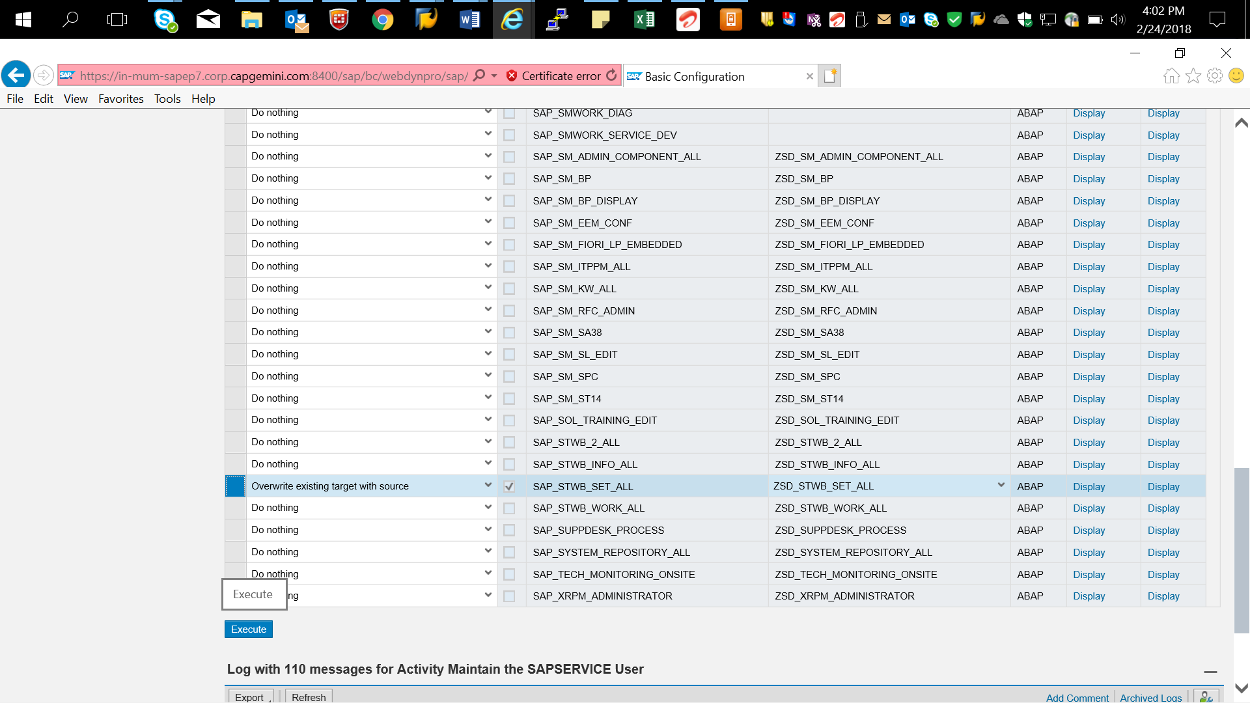



**Complete.**

This step provides an overview of the steps that have been performed in this scenario, including information about the users who made the changes, and the status of each step.

You can do the following:

* To return to a step, choose the link in the Configuration Steps column.
* To save your settings and close the scenario, choose Finish.

